MMTA COURSE ONE EXAM

Please choose the correct answer from the choices given. There may be more than one correct choice in some. Indicate your response by highlighting, underlining, or boldening the answer choice.

- What is a Cycle, as used in MMTA?

A: Something that has a motor and wheels
B: Slang word for a psychopath, or someone who acts crazy
C: A phenomenon that occurs consistently at regular intervals of time.
D: A phenomenon that always occurs at exact intervals of time.

- In financial market timing, what percentage of occurrences constitutes “consistency” in order to be considered a useful cycle for analysis and projection?

A: 90%
B: 80%
C: 66.67%
D: 70% is allowable, but >80% is preferable

- What does “Mean Periodicity” refer to?

A: The cycle length that is midway between the range points of a cycle’s “normal” occurrence.
B: The cycle length that is midway between the shortest and longest points of all the cycles of a particular grouping.
C: The average of all cycle lengths added up and divided by the number of occurrences.
D: The average of the middle 80% of cycle lengths in a particular grouping

- True or false: The “orb” of a cycle refers to the time allowable on either side of mean cycle length to still be considered part of that “normal” cycle

True
False

- What is the general orb of time used in defining a cycle’s allowable periodicity?

A: One-tenth the normal cycle length
B One-eighth the normal cycle length
C: One-sixth the normal cycle length
D: One-fifth the normal cycle length
E: One-fourth of all the cycle lengths in the grouping

- In an 18-week cycle, which is the orb of time that is generally allowable in most 18-week cycles in financial markets unless there is a formal study indicating otherwise?

A: 2 weeks
B: 3 weeks
C: 4 weeks
D: 5 weeks

- True or false: A “normal allowable orb” of time in a market cycle will be altered if actual studies show a longer or shorter orb of time in over 80% of their instances?

True
False

- What does the “range” of a cycle refer to?

A: The time band that covers the shortest and longest cycles in the study group
B: The time band that covers the mean length of a cycle plus its orb
C: All of the above
D: None of the above

- How are market cycles measured in MMTA?

A: From high to high
B: From low to low
C: From low to high
D: From high to low
- What is a trough?

A: A basin that horses drink from
B: A rounding pattern that markets make when bottoming
C: The high of a market cycle
D: The low of a market cycle

- What is a crest?

A: A basin that Scorpios drink from
B: A family’s coat of arms used on a shield when going into battle
C: The high of a market cycle
D: The low of a market cycle

- What is “Right Translation?”

A: A characteristic of bull markets
B: A market pattern in which prices rise for a longer period than they fall
C: A market pattern where the crest of a cycle occurs past the midway point of the cycle.
D: All of the above

- What is a “Cycle Distortion?”

A: A case where markets rise and fall more sharply than expected.
B: A case where the cycle low of a market falls outside of its normal time band
C: A case where the market crest falls outside of its normal time band
D: A case where the market skips a beat

- What are the two types of cycle distortions and what do they refer to? Choose more than one answer if appropriate.

A: Contraction, which refers to cycles bottoming before their normal time band
B: Contraction, which refers to cycles peaking before their normal time band
C: Expansion, which refers to cycles bottoming before their normal time band
D: Expansion, which refers to cycles bottoming later than their normal time band

- Every cycle is comprised of smaller cycles. What are the two names these smaller cycles are known as? (choose more than one answer)

A: Sub-cycles
B: Midpoints
C: Phases
D: Harmonics

- What are the three types of basic cycle patterns?

A: Primary, half-primary, and major
B: Long-term, intermediate-term, short-term
C: Two-phase, three-phase, combination
D: Left translation, center translation, right translation

- Below is a chart of a primary cycle in T-Notes. What type of cycle pattern is this?

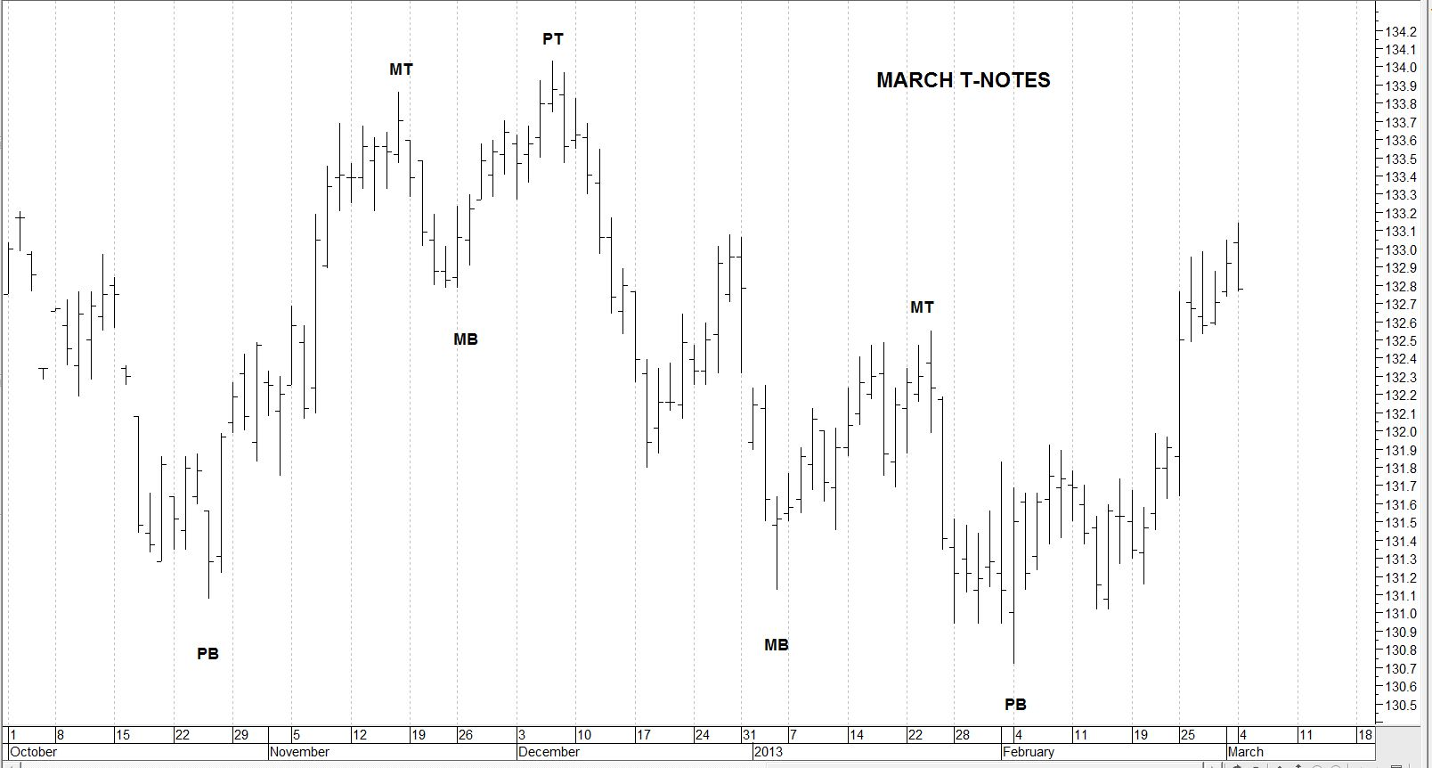

A: Three-phase pattern
B: Two-Phase Pattern
C: Combination Pattern
D: None of the above

- True or false: All markets cycles are bullish, bearish, or mixed.

True
False

- Which phase of a cycle is almost always bullish?

A: First
B: Second
C: Third
D: In a bull market, they are all bullish

- Which phase of a cycle is usually bearish or has the steepest decline in a bullish pattern?

A: First
B: Second
C: Third
D: In a bear market, they are all bearish

- Which of the following are characteristics of bull markets? (Remember: may be more than one correct answer throughout this test)

A: Consecutively lower lows (troughs) of the same cycle (or sub-cycle) type
B. Consecutively higher highs (crests) of the same cycle (or sub-cycle) type
C. Left translation pattern cycle
D. The lowest price is always the start of the cycle. There is no lower price between the start and end of a bearish cycle than where it starts.
E: All of the above

- Which of the following are characteristics of bear markets?

A: Consecutively lower lows (troughs) of the same cycle (or sub-cycle) type
B. Consecutively low highs (crests) of the same cycle (or sub-cycle) type
C. Left translation pattern cycle
D. The lowest price is always the end of the cycle. There is no lower price between the start and end of a bearish cycle than where it starts.
E: All of the above

- What is the most important consideration of all the characteristics of a cycle in determining whether it is bullish or bearish?

A: The price at the end of the cycle
B: The price at the beginning of the cycle
C: The translation pattern
D: The 8-week rule

- When should bullish strategies be applied in trading via cycles?

A: At the beginning of a cycle
B: Any time in a cycle as long as the price remains above the start of the cycle
C: In the last phase of a cycle
D: Whenever prices break out to a new cycle high
- At what point should bearish strategies be applied in trading via cycles?

A: At the beginning of a cycle
B: Any time in a cycle after the price breaks below the start of the cycle
C: In the last phase of a cycle
D: Whenever there is news that is negative for this market

- Which of these choices best describes the “The 50% Correction Rule”?

A: A market rallies from 100 to 126, and then falls back to 113
B: A market declines from 97.50 to 89.00, and then rallies back to 92.20
C: A market rallies from 132.48 to 137.50, and then pulls back to 136.06.
D: A market declines from 1664 to 1576, and then rallies back to 1620

- True or false: If Silver rallies from 27.60 to 30.24, it would be considered a corrective decline if it then pulled back to 28.55?

True
False

- The normal retracement for a “corrective decline” in a bull market would be:

A: 50%
B: 45-85%
C: 23.6 – 76.8%
D: 38.2-61.8%

- What term(s) would be associated with a normal corrective decline from the rally?

A: A Fibonacci retracement
B: A 38.2-61.8% corrective pullback
C: A wave 2
D: None of the above

- If crude oil moves from a major cycle trough at 90.00/barrel to a crest of 98.00/barrel, then what would a normal corrective decline be to its next major cycle trough, assuming this is a bull market cycle?

A: 93.00-95.00
B: 95.21-96.61
C: 93.06-94.94
D: 101.45-104.25

- True or false: A double top defines a resistance zone in financial markets?

True
False

- An upside breakout occurs when ____

A: Prices close above resistance
B: Prices trade above resistance and then close back below
C: Prices trade below support and then close back above
D: None of the above

- If the price of Silver completes a primary cycle crest at 33.50/ounce in a bear market, and then declines to a major cycle trough at 28.60/ounce, what is the price target range of a corrective rally to the crest of the next major cycle?

A: 31.05 +/- .58
B: 31.05 +/- .29
C: 38.40 +/- 1.15
D: 38.40 +/- .58

- True or false: Double bottoms happen often in long-term cycles

True
False

- Which of the following pertains to a double bottom?

A: A cycle low that is tested again after several days, week, months or even years.
B: It defines a support zone for a market
C: In bull markets, the low at the end of a cycle will often form a double bottom to the low of its prior phase
D: In bear markets, the low at the end of the cycle test the low of the previous phase, but it will be higher than the low of that previous phase

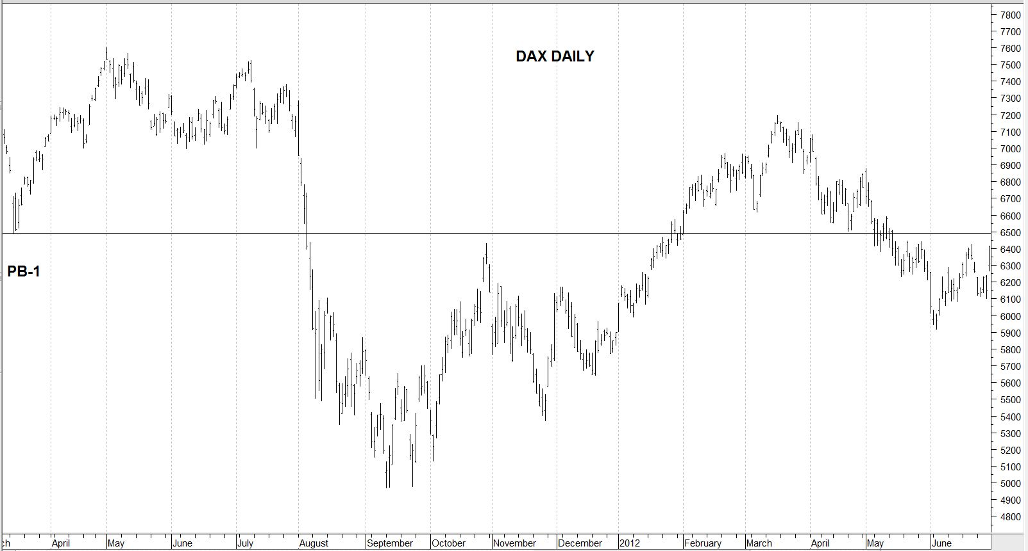

- On the chart above, what does the horizontal line represent and indicate about the DAX?

A: It represents support to the primary cycle
B: When it broke, it became a downside breakout
C: After it broke, it became resistance
D: All of the above

- Arrange the 5 steps to “Finding the Cycles within a Financial Market” in their proper order:

A: Once you find a sub-cycle, then divide these new cycles (phases) by 2 or 3 and see if further sub-cycles are present.
B: Identify the three of the most pronounced lows on this chart
C: Take the longest of these three periods and divide it by 2 and 3 to get possible sub-cycles within the potentially greater long-term cycle.
D: Take the two shorter-term periods. Add and subtract their lengths to the two dates chosen as the longest interval.
E: Start with the longest chart you can find of a given market.
F: Determine how far apart any two of these troughs are from one another. This should give you three time periods.

- In the long-term chart shown of US and British stock prices, what very long-term periods show promise of becoming valid cycles?

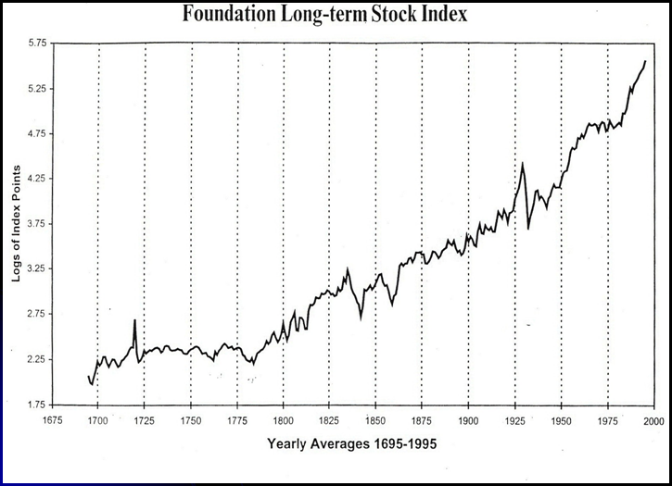

A: 42 years
B: 58 years
C: 75 years
D: 85 years

- What sub-cycle phases of the longer-term cycles in U.S. stocks seem most valid to date?

A: 25-year
B: 30-year
C: 37.5-year (or 36)
D: 42.5-year

- What has been the historical range of the 18-year cycle in USA and British Stock market?

A: 13-21 years
B: 15-21 years
C: 13-22 years
D: 15-22 years
- If you take out the shortest and longest instances, what has been the “normal” range for the 18-year cycle?

A: 13-21 years
B: 15-21 years
C: 13-22 years
D: 15-22 years

TABLE OF 18-YEAR CYCLES

Cycle # | Trough | Crest | Trough | Yrs Up | Yrs Dn | Low* | High* | Low* | % Up* | % Dn*
1. | 1797 | 1806 | 1813 | 9 | 7 | 3.0 | 8.0 | 4.0 | 166.7% | 50.0%
2. | 1813 | 1824 | 1829 | 11 | 5 | 4.0 | 15.0 | 10.5 | 275.0% | 30.3%
3. | 1829 | 1835 | 1842 | 6 | 7 | 10.5 | 25.0 | 5.0 | 138.1% | 80.0%
4. | 1842 | 1852 | 1857 | 10 | 5 | 5.0 | 22.0 | 8.0 | 340.0% | 63.6%
5. | 1857 | 1873 | 1877 | 16 | 4 | 8.0 | 36.0 | 22.5 | 350.0% | 37.5%
6. | 1877 | 1889 | 1896 | 12 | 7 | 22.5 | 50.0 | 27.0 | 122.2% | 46.0%
7. | 1896 | 1906 | 1914 | 10 | 8 | 27.0 | 102.0 | 52.0 | 277.7% | 49.0%
8. | 1914 | 1929 | 1932 | 15 | 3 | 52.0 | 386.1 | 40.6 | 642.5% | 89.5%
9. | 7/32 | 1/53 | 9/53 | 20 | 1 | 40.60 | 295.10 | 254.00 | 262.8% | 13.9%
10. | 9/53 | 1/73 | 12/74 | 19 | 2 | 254.00 | 1067.20 | 570.00 | 320.1% | 46.6%
11. | 12/74 | 8/87 | 10/87 | 12 | 1 | 570.00 | 2746.70 | 1616.20 | 381.9% | 41.2%
12. | 10/87 | 10/07 | 3/09 | 20 | 2 | 1616.20 | 14,279.96 | 6440.08 | 883.5% | 54.4%

- Using the above table of 18-year cycles in stocks, what is the historical range of time it has taken the stock market to rise from the start to the crest of the 18-year cycle?

A: 6-16 years
B: 12-20 years
C: 6-20 years
D: None of the above

- What has been the historical range for percentage of gain from the trough to the crest of the 18-year cycle so far?

A: 262-993%
B: 262-883%
C: 166-883%
D: 122-883%

- Historically, how long have declines lasted from the crest to the end of the 18-year cycle?

A: 1-3 years
B: 1-7 years
C: 1-8 years
D: 2-7 years

- Historically, what has been the percentage of decline from the crest to the end of the 18-year cycle?

A: 50-90%
B: 30-90%
C: 20-90%
D: 13-90%

- How many 18-year cycles have exhibited “left translation?”

A: 1
B: 2
C: 3
D: none

- Of the twelve 18-year cycles to date, how many declined at least 37.5%?

A: 1
B: 5
C: 10
D: 11

- Which was the longest 18-year cycle to date?

A: #5
B: #6
C: #9
D: #12

- What are the normal lengths of the sub-cycles within the 18-year cycle?

A: 6 years
B: 6 and 9 years
C: 9 years
D: 10 years

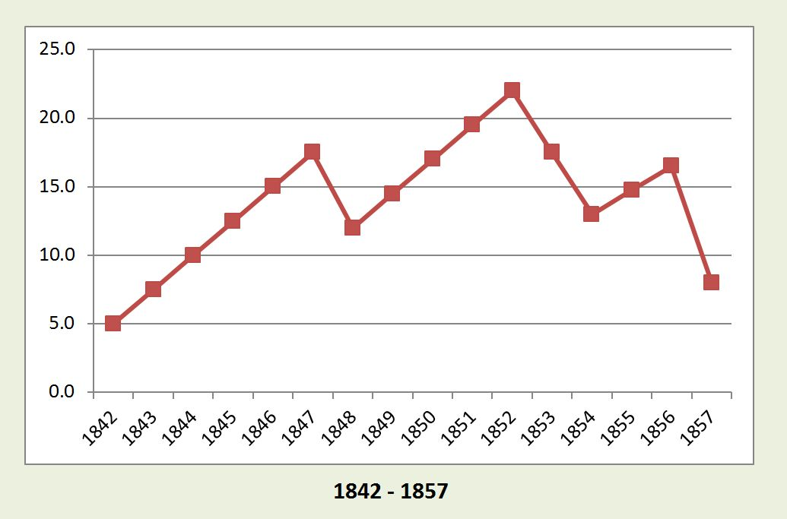

- In the chart above, what is the pattern of this 18-year cycle?

A: Combination
B: Variation
C: Two-phase
D: Three-phase

- In the chart above, what characteristic is exhibited in the last phase?

A: Distortion
B: Expansion
C: Contraction
D: Double Bottom

- Which of the following would be correct chains of long-term cycles in U.S. stock market?

A: 144-year, 72-year, 36-year, and 18-year
B: 148-year, 75-year, 37.5-year, 18.75-year
C: 90-year, 45-year, 22.5-year, 7.5-year
D: 85-year, 42.5-year, 22-year, 11-year

- Historically, what is the interval of time between a long-term cycle low (over 50 years) in the USA stock market and its secondary low?

A: 1-3 years
B: 3-8 years
C: 5-8 years
D: 6-22 years

- True or false: Secondary lows seldom form after every 18-year or greater cycle?

True
False

The following questions are based on the Table of 4-Year cycles

TABLE OF 4-YEAR CYCLES

- What is the shortest 4-year cycle since 1932?

A: 30 months
B: 31 months
C: 36 months
D: 39 months

- What percentage of 4-year cycles have had rallies to their crest that lasted more than 49 months?

A: 5%
B: 10%
C: 20%
D: None has ever lasted more than 49 months

- What is the normal range of a 4-year cycle in U.S. stocks?

A: 36-56 months
B: 38-62 months
C: 40-54 months
D: 38-54 months

- What percentages of 4-year cycles have exhibited a decline of over 19% from their crest to trough?

A: 50%
B: More than 60%
C: More than 70%
D: More than 80%

- True or False: The first 4-year cycle phase of a longer-term cycle has declined at least 19% in every instance since 1893.

True
False

- What percent of 4-year cycles see the stock market rally 39-180%?

A: 50%
B: More than 60%
C: 75%
D: 80%
- Prior to the current cycle, what percent of 4-year cycles had seen the stock market rally at least 99%?

A: 25%
B: 33%
C: 40%
D: more than 50%

- What percent has the current 4-year cycle rallied from its trough in March 2020 to the high so far present in the DJIA?

A: Approximately 50%
B: Approximately 75%
C: Approximately 100%
D: More than 125%

- What are the two basic cycle phases in the 4-year cycle?

A: 18 and 27 months
B: 15.33 and 22.5-months
C: 50- and 68-weeks
D: None of the above

- How does the 22.5-month cycle usually break down?

A: Two 50-week cycles
B: Three 7.5-month cycles
C: Two 50-week cycles followed by a 7.5-month cycle
D: One 50-week cycle and two 7.5-month cycles

- What is the average length of the first 15.33-month cycle in a 4-year cycle in U.S. stocks?

A: 14.30 months
B: 15.33 months
C: 16.50 months
D: 17.33 months

- What is the average length of the last 15.33-month cycle in a 4-year cycle in U.S. stocks?

A: 14.45 months
B: 15.33 months
C: 16.70 months
D: 17.33 months

- The range of the third 15.33-month cycle in U.S. stocks has been:

A: 6-19 months
B: 8-23 months
C: 10-27 months
D: 10-20 months

- The USA Presidential Cycle tends to bottom:

A: In the first year of the president’s term
B: In the second year of the president’s term
C: In the third year of the president’s term
D: 16-25 months after the election

- Which of the following statements are true?

A: The current 4-year cycle has witnessed an all-time high in the DJIA
B: The current 4-year cycle is still in its first phase
C: The previous 4-year cycle bottomed within a normal range
D: All of the above

- Which of the following statements is true?

A: Over 90% of 50-week cycles occur in a range of 34-67 weeks
B: The “normal” range for a 50-week cycle is 38-62 weeks
C: There are usually two 50-weeks cycles present in a 15.5-month cycle
D: All of the above

- True or false: Historically, there have been mostly five instances of four-year cycles within the 18-year cycle in U.S. stock indices

True
False

For the next questions, use this weekly chart of the DJIA

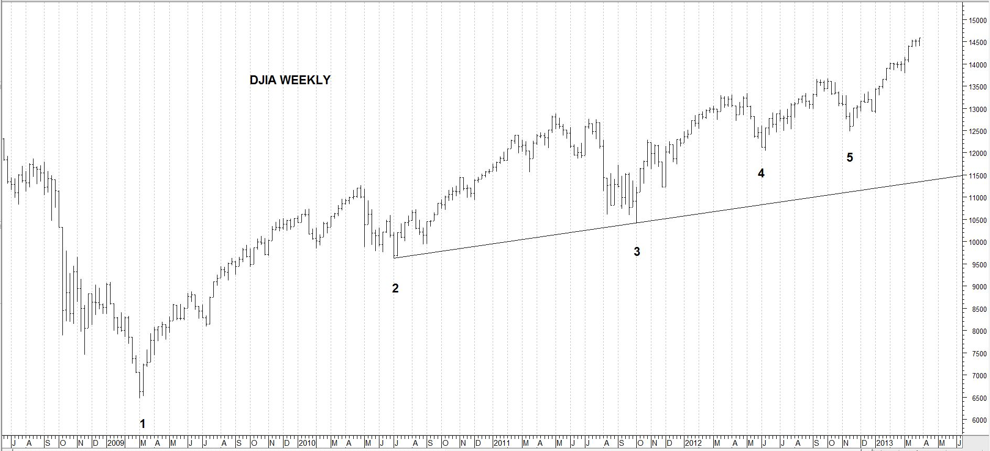

- In the chart above, what type of cycle occurred at 1 (March 2009)?

A: 72-and 36-year
B: 18- and 6-year
C: 4-year
D: All of the above

- What type of cycle occurred at 2?

A: 50-week
B: 15.33-month
C: 22.5-month
D: All of the above

- What type of cycle occurred at 3?

A: 50-week
B: 15.33-month
C: 22.5-month
D: Distorted 4-year cycle low
- What type of cycle(s) occurred at 4?

A: Primary cycle
B: 32.5-week cycle
C: Half-cycle to the 15.33-month cycle
D: All of the above

- What type of cycle may have occurred at 5?

A: 15.33-month cycle
B: The second phase of an expanded 15.33-month cycle
C: An expanded primary cycle
D: All of the above are possible

- Which of the following figures is correct regarding primary cycles in the DJIA?

A: Primary cycles have occurred in a range of 13-26 weeks in over 93% of cases
B: Primary cycles have occurred in a range of 13-24 weeks in over 85% of cases
C: The normal range used for the DJIA primary cycle is 13-21 weeks
D: All of the above

- True or false: The 18-day standard CCI bottoming below -200 indicates an important low in Silver could happen within the next 7 trading days.

True
False

- True or false: If the 18-day CCI in Silver exceeds +200, it indicates an important top could happen within the next 7 trading days, after which Silver declines at least 9%.

True
False

- If a 9% or greater reversal doesn’t begin within 7 trading days after the CCI exceeds -200 or +200, then what can indicate another buy or sell signal?

A: Bullish oscillator divergence where Silver falls lower but CCI doesn’t make a new low
B: Bullish oscillator divergence where Silver makes a new high but CCI doesn’t make a new high
C: Either of the above
D: Neither of the above
- The following can represent buy signals in Silver

A: Intermarket bullish divergence to Gold at any time in the primary cycle
B: Intermarket bullish divergence to Gold if one of the lows occurred in a time band when the primary cycle trough was due
C: Bullish oscillator in the CCI after the first low coincided with a CCI reading below -200
D: All of the above

- When did the last two confirmed 18-year cycle troughs occur in T-Notes? Choose two answers from below.

A: 1984
B: 2000
C: 2006
D: 2018

- What pattern formed in the prior 18-year cycle in T-Notes?

A: Three-pattern of three 6-year cycles
B: Two-phase pattern of two 9-year cycles
C: A combination pattern
D: All of the above

- What is the normal range of the primary cycle in Crude Oil?

A: 13-21 weeks
B: 15-21 weeks
C: 15-23 weeks
D: 15-26 weeks

- What is the normal range of the primary cycle in Soybeans?

A: 13-21 weeks
B: 15-21 weeks
C: 15-23 weeks
D: 15-26 weeks

- What is the normal range of the primary cycle in the Euro currency?

A: 13-21 weeks
B: 15-21 weeks
C: 15-23 weeks
D: 23-37 weeks

- What is the normal range of the primary cycle in the Dollar-Yen currency?

A: 26-40 weeks
B: 15-21 weeks
C: 15-23 weeks
D: 23-37 weeks

- What is the normal range of the major cycle in the Dollar-Yen currency?

A: 5-7 weeks
B: 5-8 weeks
C: 7-11 weeks
D: 9-14 weeks

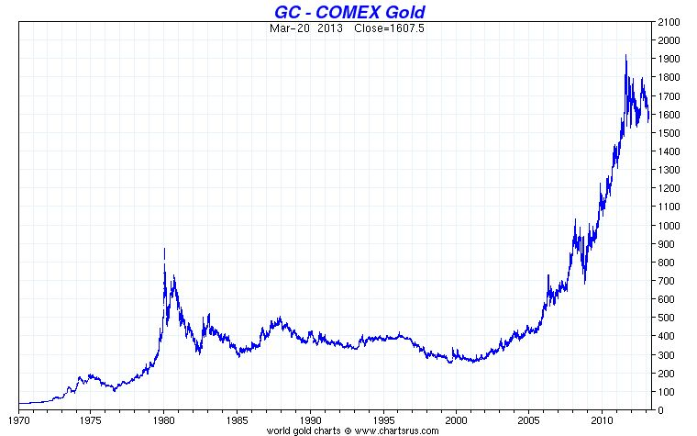

- From the chart above, what are the years of the most important and longest-term cycle in Gold?

A: 1976 and 1985
B: 1985 and 1999-2001
C: 1999-2001 and 2008
D: 1976 and 1999-2001
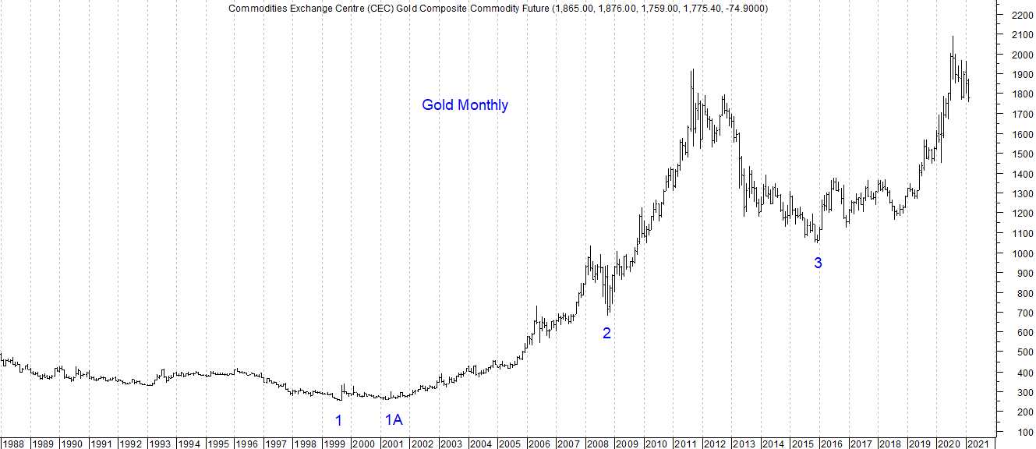

- In the chart of Gold above, what long-term cycles formed at 1 and 1A?

A: 8.5-year
B: 18-year
C: 23.5-year
D: 30-year

- What long-term cycle formed at 2?

A: 7.83-year
B: 18-year
C: 25-year
D: 30-year

- What phases can comprise the 7.83-year Gold cycle?

A: A 2-phase cycle of two 3.915-year sub-cycles
B: A 3-phase cycle of three 31.33-month sub-cycles
C: A combination pattern of each
D: None of the above

- Gold is in the early-stages of a new 23.5-year cycle.

True
False
- In a three-phase pattern off the low in December 2015 (3), when would end of the second phase of its three-phase pattern be due?

A: March-April 2021 +/- 6 months
B: October 2022 +/- 3 months
C: January 2020 +/- 3 months
D: February 2023 +/- 17 months

- If the current Gold market is falling into a 31.33-month cycle trough, which of the following conditions would be expected?

A: It would break 1767
B: The 17-month moving average would probably fall below the 26-month average
C: A normal price target would be about 1628 +/- 109
D: All of the above

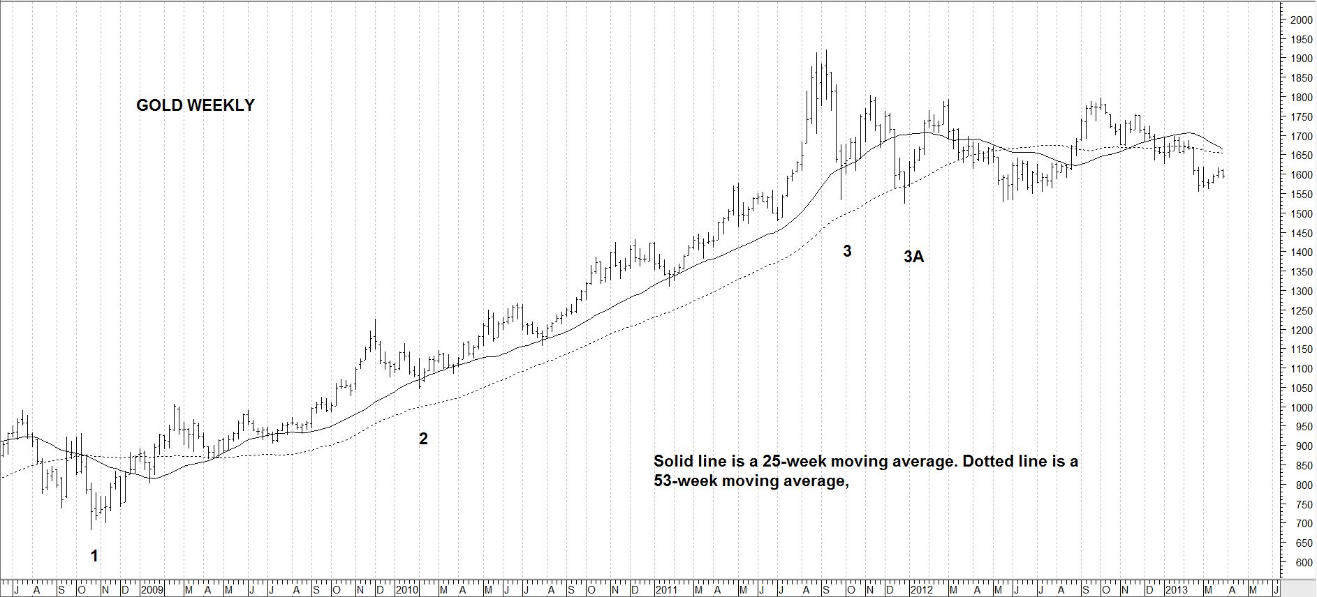

- In the weekly chart above, what cycles are indicated by 1, 2, and 3-3A?

A: The 11.33-month cycle phases of the 34- (or 31.33-) month cycle
B: The 17-month cycle phases of the 34-month cycle
C: The 17-month cycle phases of the 4.25-year cycle
D: The 23-month cycle phases of the 5.5-year cycle

- What does it mean if the 25-week moving average falls below the 53-week average?

A: It means Gold’s weekly chart is in a trend run down
B: It probably means Gold is falling to its third 17-month cycle phase in a greater 4.25-year cycle
C: Both will then represent major resistance to a bear market in Gold
D: All of the above

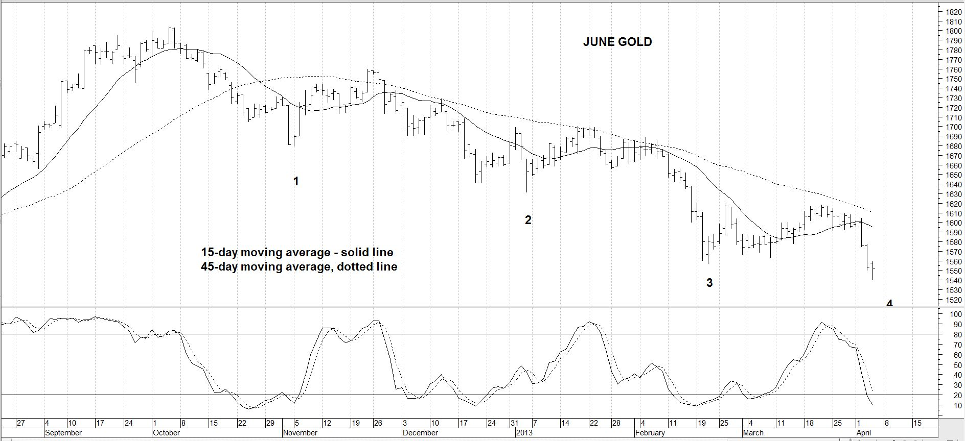

- In the daily chart of June Gold above, 1 is a primary cycle trough. Did Gold ever confirm its next primary cycle trough at 3? Why or why not?

A: No. It never closed back above the 45-day moving average after 3.
B: Yes. It closed above 15-day moving average.
C: No. It never made a new cycle high at least two weeks after the low at 3.
D: Yes. It made a double top at least two weeks after 3, even though it was lower than the first crest.

- What did the stochastics do at 3 and what did that imply?

A: They were below 20%, which meant it was a primary cycle trough
B: They formed a case of bullish oscillator divergence, which implied it was a primary cycle trough
C: They formed a bullish double looping bottom at a double bottom shortly afterwards, which implied 3 could be a primary cycle trough.
D: They didn’t tell us anything

100: Which of the following statements is true?

A: The Dollar/Yen has exhibited cases of a possible 16.5-year cycle
B: The Dollar/Yen has exhibited cases of a possible 5.5-year cycle
C: Gold’s longest-term cycle known so far has a recent history of sub-dividing into three phases of 7.83- sub-cycles or phases
D: Gold’s 7.83-year cycle has a recent history of sub-dividing into three phases of 31.33-month phases
E: All of the above are correct

